**Text and Image Module:**

* Rename “Container Type” as “Layout Type”.
  + Rename the option “Text” as “Text Only”
* Image option in not needed. The below one is wrongly mapped as “Text and Image” in the component variation sheet. This is already covered under “Image” module’s full width option (Large)

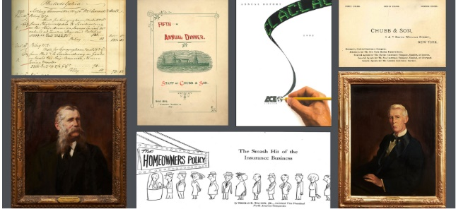

* In the Mock up, I select “Text” in the drop down. Then when I click the drop down again, it is broken. Please fix it
* Make Description also as optional for flexibility (in all options)
* Rename “Text background Color” as “Background color” in all places in this module

**Video with Text Option:**

* Videos can either be from Brightcove or You tube. So it should be implemented like this

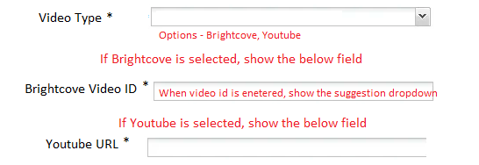

* Need a field for “Video Image to Override” (optional)
  + If an image is selected, then this will be used. If not, the default image from the video will be used
  + For this field, add Decorative & Alt text field
* Rename “Image position” as “Video Position”
  + Only options should be” Left” & “Right”
  + If the selection in multi column module is “1”, then this field will be shown (as it is full width)
  + For any other selection in multi column, this filed is not needed since the video will always be at top and text will be below that
* The below fields are not needed
  + For consistency, we can have 50% for text and remaining 50% for image / video



**Image with Text option:**

* The below options are not needed



* Instead add a checkbox to - “Do you want to show a detailed Info graphic Image?”
  + If Checked – the zoom icon should auto appear. Just ask for the below fields
    - Icon Position – Options are Left, Right
    - Icon Background color
    - Full Infographic Image – A image selector
    - Decorative Image field and Alt text field for this Full Infographic image field
* For “Image position” field:
  + Only options should be” Left” & “Right”
  + If the selection in multi column module is “1”, then this field will be shown (as it is full width)
  + For any other selection in multi column, this filed is not needed since the video will always be at top and text will be below that